**CS359 - Computer Network Lab**

**Lab 4**

**Socket Programming**

Tarusi Mittal 1901CS65

The folder contains three files:

1 server.c

2 client.c

3 sample.txt

**Server Side Code: server.c**

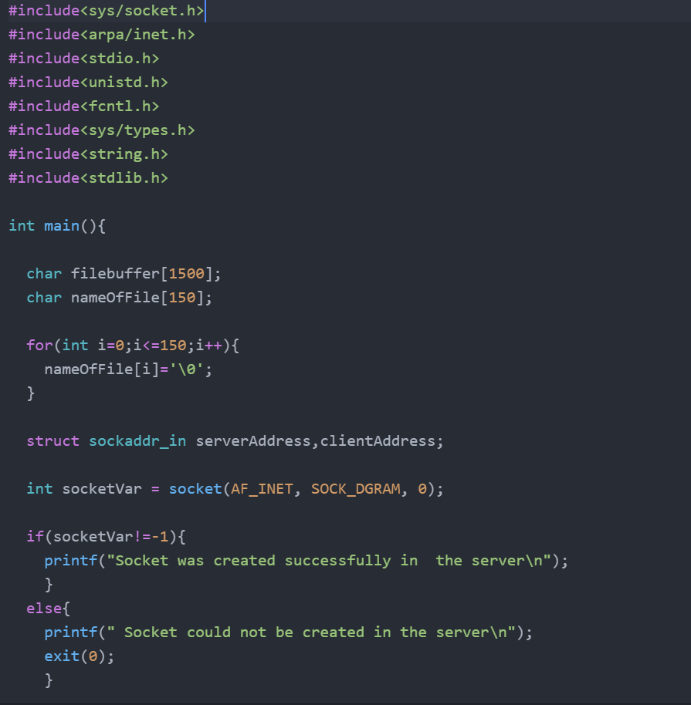

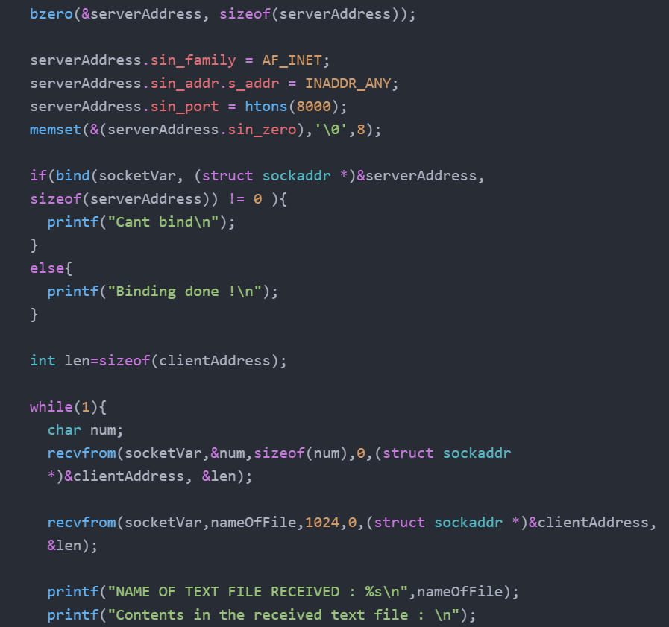

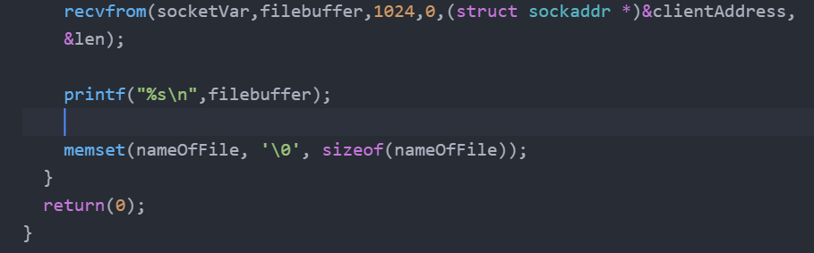

**Client Side Code: client.c**

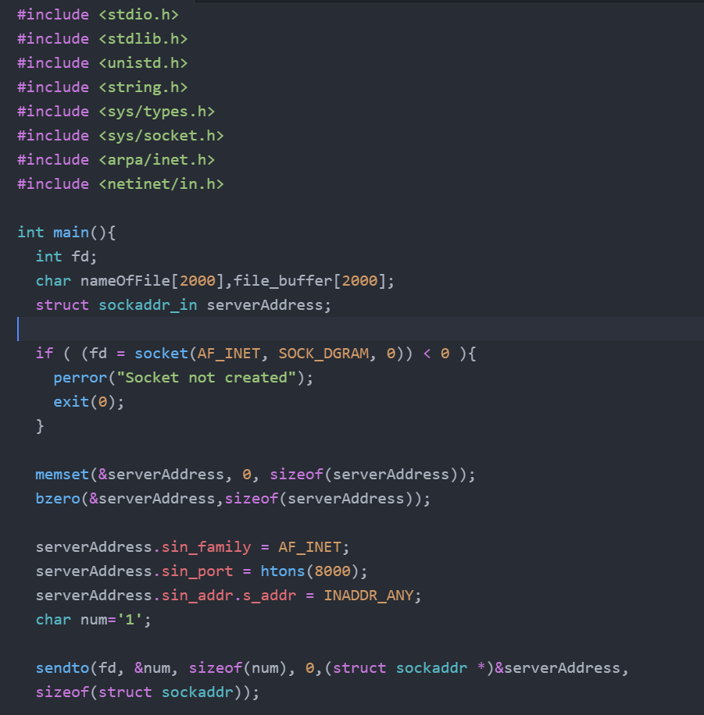

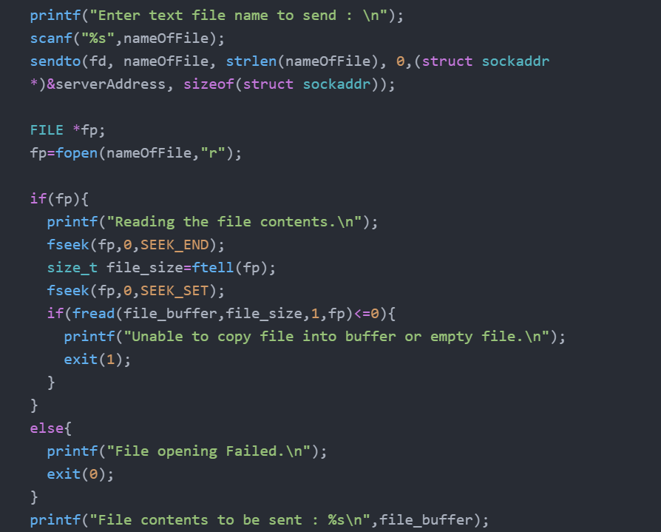

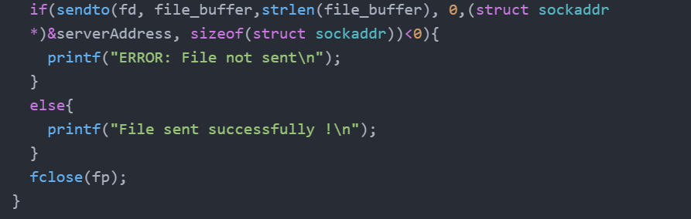

***Output:***

**Client**

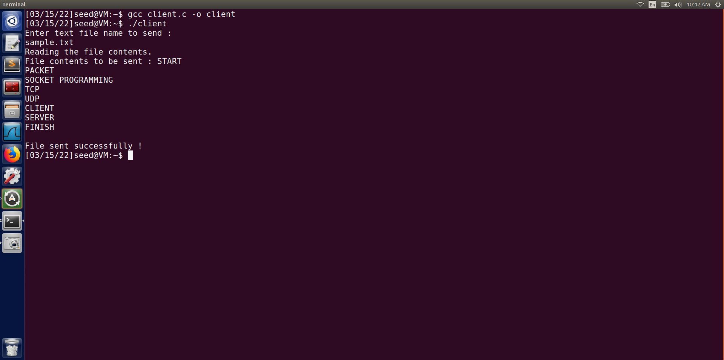

**Server**

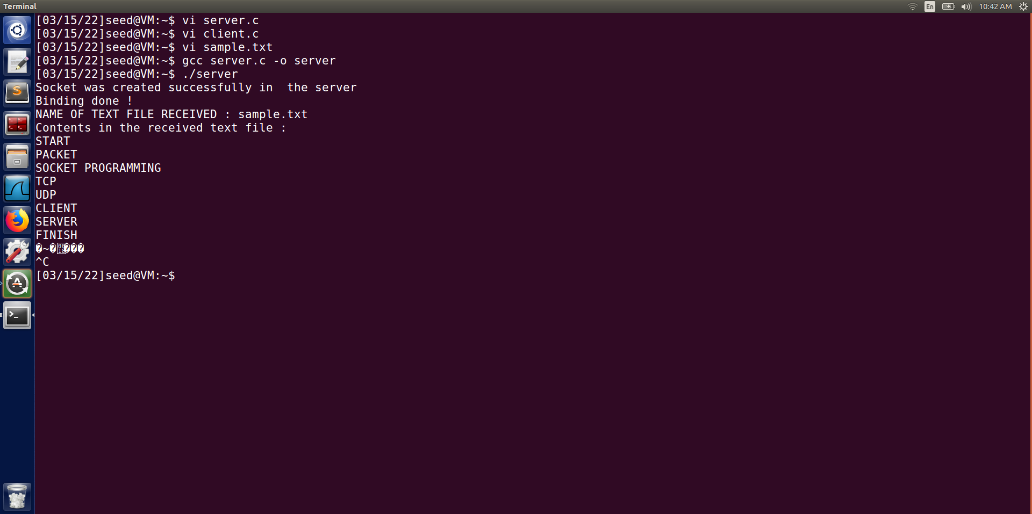

END